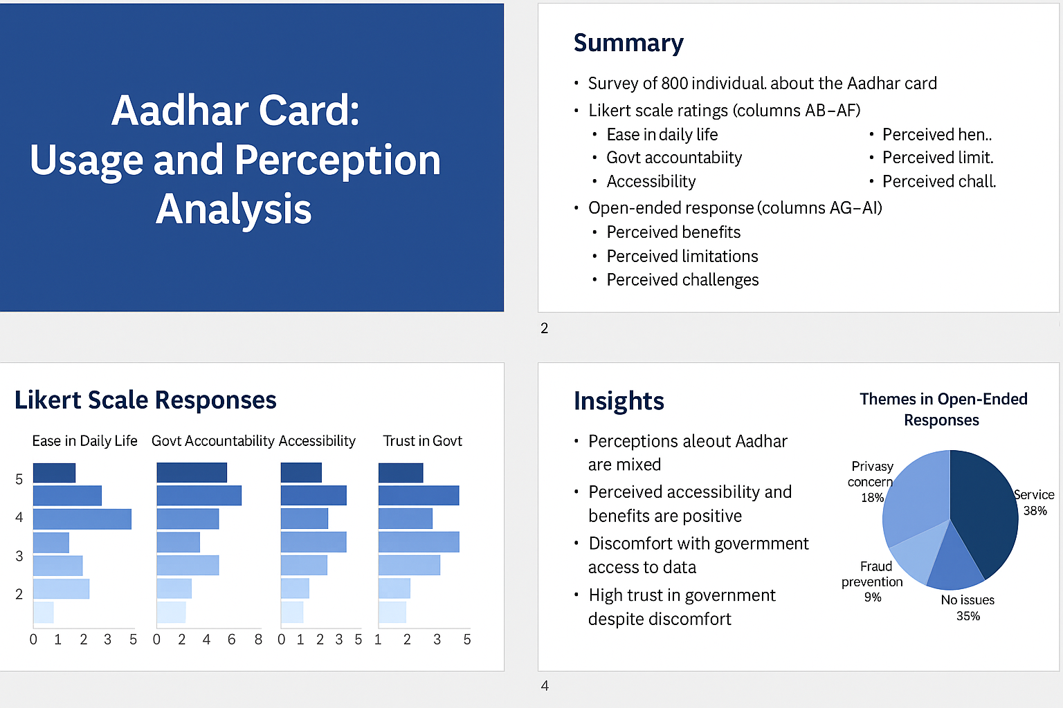

AADHAR DATA ANAYSIS

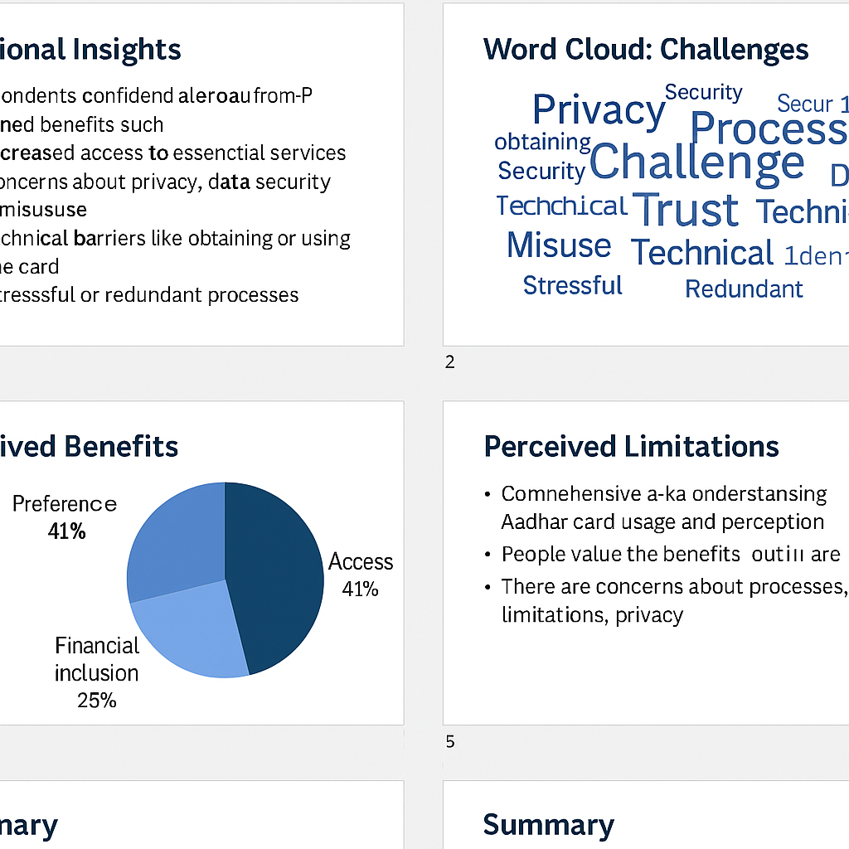

**RELATION ANALYSIS (PART A)**

(**NOTE: NO duplicates found)**

### REGRESSION ANALYSIS

### **MODEL 1**

Dependent variable: PLUM How much do you trust the government

Independent variable: Gender and Professional Status

Using ORDINAL REGRESSIOIN since the dependent variable is ordered

#### Goodness-of-Fit

CONCLUSION

The model has some explanatory power, but there may be other factors or variables that could further improve the model's fit and predictive ability.

|  |  |  |  |
| --- | --- | --- | --- |
| **Goodness-of-Fit** | | | |
|  | Chi-Square | df | Sig. |
| Pearson | 37.948 | 41 | .607 |
| Deviance | 40.996 | 41 | .471 |
| Link function: Logit. | | | |

**Interpretation**

1. Non-significant p-values: Both tests indicate a good fit (p > 0.05).

2. Model fits the data: The model adequately represents the data.

### Pseudo R-Square

CONCLUSION

The model has some explanatory power, but there may be other factors or variables that could further improve the model's fit and predictive ability.

|  |  |
| --- | --- |
| **Pseudo R-Square** | |
| Cox and Snell | .029 |
| Nagelkerke | .034 |
| McFadden | .016 |
| Link function: Logit. | |

**Interpretation**

The pseudo R-square values indicate a weak fit, suggesting that the model explains only a small proportion of the variance in the outcome variable.

* Key Findings from Parameter Estimates : -

1.Significant predictors: - Gender (male vs. female)

[Being male is associated with lower trust in government (Estimate = -0.754, p < 0.001) ]

2. Non-significant predictors:- Professional Status (all categories)

[None of the professional status categories are significant predictors of trust in government]

**Conclusion**:

The model suggests that gender is a significant predictor of trust in government, while professional status is not. This may indicate that other factors are more important in determining trust in government.

**Key Findings**

1. Trust in Government:

- Most respondents trust the government (58.0% "Very trustworthy" and 34.6% "Somewhat trustworthy").

- Only 1.3% "Distrust" and 1.5% "Somewhat distrust".

2. Gender - 62.1% of respondents are male, and 37.9% are female.

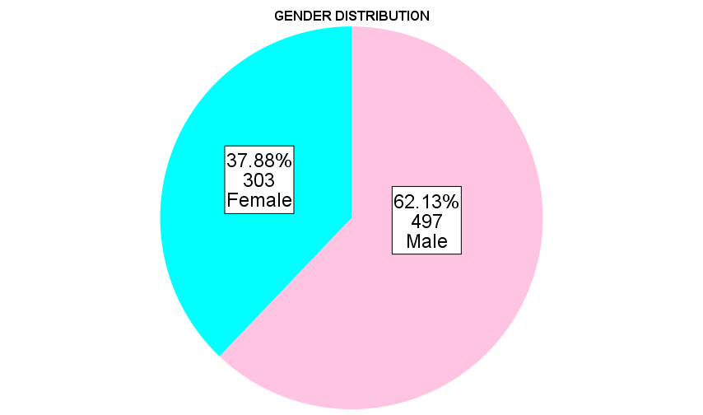

3. Professional Status:

- Most respondents are self-employed/business (49.4%) or salaried employees (22.5%).

- Students (13.6%) and unemployed (1.8%) make up smaller proportions.

- Dominant professional groups: Self-employed/business and salaried employees are the largest groups.

## **MODEL 2**

* Dependent variable: How much do you trust the government
* Independent variable: how hard it is to get aadhar card, how much aadhar contributes to make life easier and aadhar card makes government accountable
* Ordinal Regression Analysis

### Goodness-of-Fit

CONCLUSION

The model has some explanatory power, but there may be other factors or variables that could further improve the model's fit and predictive ability.

|  |  |  |  |
| --- | --- | --- | --- |
| **Goodness-of-Fit** | | | |
|  | Chi-Square | df | Sig. |
| Pearson | 284.025 | 160 | .000 |
| Deviance | 172.363 | 160 | .239 |
| Link function: Logit. | | | |

**Interpretation**

The Pearson Chi-Square test suggests a poor fit, while the Deviance test indicates a good fit. This discrepancy may be due to the specific characteristics of the data or model.

### Pseudo R-Square

CONCLUSION

The model has some explanatory power, but there may be other factors or variables that could further improve the model's fit and predictive ability.

|  |  |
| --- | --- |
| **Pseudo R-Square** | |
| Cox and Snell | .233 |
| Nagelkerke | .275 |
| McFadden | .141 |
| Link function: Logit. | |

**Interpretation**

The pseudo R-square values indicate a moderate fit, suggesting that the model explains a notable proportion of the variance in the outcome variable.

* **Key Findings**

Significant predictors are

1. Perception of Aadhar's impact on government accountability (categories 2, 3, and 4)

Respondents who perceive Aadhar as making the government more accountable are more likely to have higher trust in government.

1. Ease of getting an Aadhar card (categories 1, 2, and 4)

Difficulty in getting an Aadhar card is associated with lower trust in government.

1. Perceived ease of life with Aadhar card (categories 2 and 4)

Respondents who perceive Aadhar as making life easier are more likely to have higher trust in government.

**Conclusion:** The model suggests that perceptions of Aadhar's impact on government accountability, ease of getting an Aadhar card, and perceived ease of life with Aadhar card are significant predictors of trust in government.

## **CORRELATION ANALYSIS**

**Partial Correlation Analysis**

|  |  |  |  |  |  |  |
| --- | --- | --- | --- | --- | --- | --- |
| **Correlations** | | | | | | |
|  | | |  |  |  |  |
| Control Variables | | | ease_life | Do you have an Aadhar Card | category | Should Aadhar Card be made mandatory for the following items? |
| Gender & Age | ease_life | Correlation | 1.000 | -.224 | .001 | -.266 |
| Significance (2-tailed) | . | .000 | .978 | .000 |
| df | 0 | 796 | 796 | 796 |
| Do you have an Aadhar Card | Correlation | -.224 | 1.000 | .015 | .184 |
| Significance (2-tailed) | .000 | . | .682 | .000 |
| df | 796 | 0 | 796 | 796 |
| category | Correlation | .001 | .015 | 1.000 | .060 |
| Significance (2-tailed) | .978 | .682 | . | .088 |
| df | 796 | 796 | 0 | 796 |
| Should Aadhar Card be made mandatory for the following items? | Correlation | -.266 | .184 | .060 | 1.000 |
| Significance (2-tailed) | .000 | .000 | .088 | . |
| df | 796 | 796 | 796 | 0 |

The output shows the partial correlation analysis between following Variables

1. Ease of Life with Aadhar Card (ease_life)

2. Possession of Aadhar Card (Do you have an Aadhar Card)

3. Category

4. Mandatory Aadhar Card (Should Aadhar Card be made mandatory for the following items?)

Control Variables: Gender & Age (findings provide insights into the relationships b/w variables while controlling for Gender and Age.)

* **Key Findings**

1) Negative correlation between ease_life and Do you have an Aadhar Card: r = -0.224, p < 0.001. Respondents who have an Aadhar Card tend to find it less easy to make their life easier (negative correlation).

2) Negative correlation between ease_life and Mandatory Aadhar Card: r = -0.266, p <0.001. Respondents who think Aadhar Card should be mandatory tend to find it less easy to make their life easier

3. Positive correlation between Do you have an Aadhar Card and Mandatory Aadhar Card: r = 0.184, p < 0.001. Respondents who have an Aadhar Card are more likely to think it should be mandatory.

**Bivariate Correlation Analysis**

|  |  |  |  |  |  |
| --- | --- | --- | --- | --- | --- |
| **Correlations** | | | | | |
|  | | Should Aadhar Card be made mandatory for the following items? | Religion | category | Professional Status |
| Should Aadhar Card be made mandatory for the following items? | Pearson Correlation | 1 | .007 | .061 | .043 |
| Sig. (2-tailed) |  | .836 | .084 | .230 |
| N | 800 | 800 | 800 | 800 |
| Religion | Pearson Correlation | .007 | 1 | .267** | -.067 |
| Sig. (2-tailed) | .836 |  | .000 | .058 |
| N | 800 | 800 | 800 | 800 |
| category | Pearson Correlation | .061 | .267** | 1 | -.016 |
| Sig. (2-tailed) | .084 | .000 |  | .651 |
| N | 800 | 800 | 800 | 800 |
| Professional Status | Pearson Correlation | .043 | -.067 | -.016 | 1 |
| Sig. (2-tailed) | .230 | .058 | .651 |  |
| N | 800 | 800 | 800 | 800 |
| **. Correlation is significant at the 0.01 level (2-tailed). | | | | | |

The output shows the correlation analysis between Variables

1. Mandatory Aadhar Card (Should Aadhar Card be made mandatory for the following items?) 2. Category 3. Mobile phone connections 4. File income tax/pancard

* **Key Findings**

1. Positive correlation between Mandatory Aadhar Card and Mobile phone connections: r = 0.321, p < 0.01

2. Positive correlation between Mandatory Aadhar Card and File income tax/pancard: r = 0.218, p < 0.01

3. Positive correlation between Mobile phone connections and File income tax/pancard: r = 0.239, p < 0.01

**Interpretation**

1. Respondents who think Aadhar Card should be mandatory for mobile phone connections and filing income tax/pancard are more likely to support mandatory Aadhar Card.

2. There is a positive relationship between supporting Aadhar Card for mobile phone connections and filing income tax/pancard.

These findings indicate a potential pattern of support for Aadhar Card across different services.

**LIKERT SCALE ANALYSIS (PARTB)**

Renaming the Likert variables as below:

| **Variable Name** | **Description** |
| --- | --- |
| ease_life | How much easier will an Aadhar Card make your daily life |
| govt_account | Do you think Aadhar has made the government for accountable |
| easy_get | How easy or hard do you think it is to get an Aadhar card |
| comfort_access | How comfortable or uncomfortable are you with the government having access |
| trust_govt | How much do you trust the government |

|  |  |  |  |  |  |  |
| --- | --- | --- | --- | --- | --- | --- |
| **Descriptive Statistics** | | | | | | |
|  | N | Range | Minimum | Maximum | Mean | Std. Deviation |
| easy_life | 800 | 4 | 1 | 5 | 4.59 | .725 |
| govt_account | 800 | 4 | 1 | 5 | 4.43 | .776 |
| ease_get | 800 | 4 | 1 | 5 | 4.12 | 1.047 |
| comfort_access | 800 | 4 | 1 | 5 | 1.24 | .699 |
| trust_govt | 800 | 4 | 1 | 5 | 4.47 | .763 |
| Valid N (listwise) | 800 |  |  |  |  |  |

**Reliability test (Cronbach’s Alpha)**

|  |  |  |  |
| --- | --- | --- | --- |
| **Case Processing Summary** | | | |
|  | | N | % |
| Cases | Valid | 800 | 39.2 |
| Excludeda | 1240 | 60.8 |
| Total | 2040 | 100.0 |
| a. Listwise deletion based on all variables in the procedure. | | | |

**Goal:** Test if the 5 Likert-scale items (Q1 to Q5) measure the same underlying construct (e.g., perception toward Aadhar). A Cronbach’s alpha of **≥ 0.70** is considered acceptable reliability.

|  |  |
| --- | --- |
| **Reliability Statistics** | |
| Cronbach's Alpha | N of Items |
| .543 | 5 |

### **Interpretation:**

* **0.5 ≤ α < 0.6** → This suggests **poor internal consistency** among the items.
* The items may not all be measuring the same underlying concept (e.g., general trust or perception of Aadhar/government).
* This could be due to:
* Conceptual differences between the questions (e.g., "ease of getting Aadhar" might not reflect trust or government comfort).
* One or more items not aligning well with the rest

### Investigating the cause of low score:

The item **“Comfort with Government Access”** might be **reverse-coded** (e.g., 1 = very comfortable, 5 = very uncomfortable), while the others go in the opposite direction (higher = more trust).

**SOLUTION :** need to **reverse the scale** for that item before rerunning the test.

### **FREQUENCY ANALYSIS**

|  |  |  |  |  |  |  |
| --- | --- | --- | --- | --- | --- | --- |
| **Statistics** | | | | | | |
|  | | easy_life | govt_account | ease_get | comfort_access | trust_govt |
| N | Valid | 800 | 800 | 800 | 800 | 800 |
| Missing | 1240 | 1240 | 1240 | 1240 | 1240 |
| Median | | 5.00 | 5.00 | 5.00 | 1.00 | 5.00 |
| Mode | | 5 | 5 | 5 | 1 | 5 |

1. **Frequency Table: Ease in Daily Life**

|  |  |  |  |  |  |
| --- | --- | --- | --- | --- | --- |
| **ease_life** | | | | | |
|  | | Frequency | Percent | Valid Percent | Cumulative Percent |
| Valid | Very difficult | 3 | .1 | .4 | .4 |
| Difficult | 4 | .2 | .5 | .9 |
| No difference | 83 | 4.1 | 10.4 | 11.3 |
| Somewhat easier | 141 | 6.9 | 17.6 | 28.9 |
| Very easy | 569 | 27.9 | 71.1 | 100.0 |
| Total | 800 | 39.2 | 100.0 |  |
| Missing | System | 1240 | 60.8 |  |  |
| Total | | 2040 | 100.0 |  |  |

**Bar Chart**

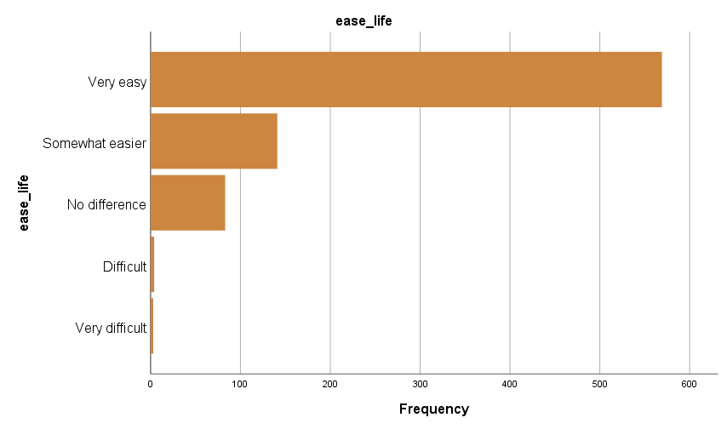

* **Findings**
* Most respondents rated Aadhar as moderately helpful in making daily life easier.
* A central tendency around the mid-point (rating 3) suggests a mixed perception—people find Aadhar somewhat useful but not transformative.

**Insights from Case Processing Summary:**

1. Positive impact: 71.1% of respondents believe that services have made life "Very easy", and 17.6% believe it has made life "Somewhat easier".
2. Minimal impact: 10.4% see "No difference".

**2.Frequency Table: Government Accountability**

|  |  |  |  |  |  |
| --- | --- | --- | --- | --- | --- |
| **govt_account** | | | | | |
|  | | Frequency | Percent | Valid Percent | Cumulative Percent |
| Valid | More corrupt | 1 | .0 | .1 | .1 |
| Somewhat corrupt | 4 | .2 | .5 | .6 |
| Not accountable | 125 | 6.1 | 15.6 | 16.3 |
| Somewhat accountable | 193 | 9.5 | 24.1 | 40.4 |
| Very accountable | 477 | 23.4 | 59.6 | 100.0 |
| Total | 800 | 39.2 | 100.0 |  |
| Missing | System | 1240 | 60.8 |  |  |
| Total | | 2040 | 100.0 |  |  |

Bar Chart

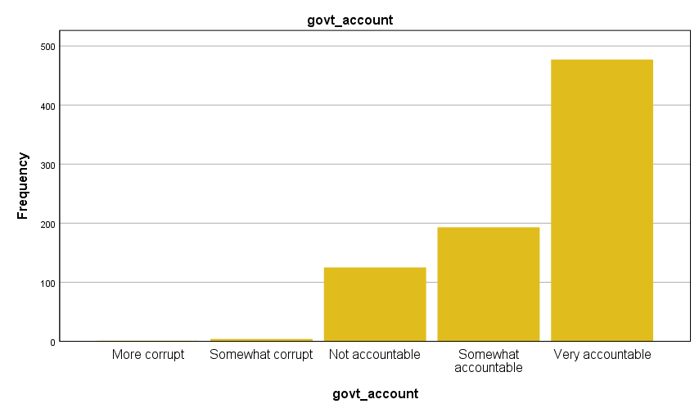

* FINDINGS
* Responses lean slightly towards agreement that Aadhar increases government accountability.
* A pattern of 3s and 4s (on a scale of 1 to 5) indicates optimism about transparency and tracking benefits.

Insights from Case Processing Summary:

1. High accountability: 59.6% of respondents believe the government is "Very accountable", and 24.1% believe it is "Somewhat accountable".

1. Low corruption perception: Only 0.1% perceive the government as "More corrupt", and 0.5% as "Somewhat corrupt".
2. **Frequency Table: Ease/hard to get aadhar**

|  |  |  |  |  |  |
| --- | --- | --- | --- | --- | --- |
| **easy_get** | | | | | |
|  | | Frequency | Percent | Valid Percent | Cumulative Percent |
| Valid | Very hard | 12 | .6 | 1.5 | 1.5 |
| Hard | 35 | 1.7 | 4.4 | 5.9 |
| Neutral | 219 | 10.7 | 27.4 | 33.3 |
| Somewhat easy | 113 | 5.5 | 14.1 | 47.4 |
| Very easy | 421 | 20.6 | 52.6 | 100.0 |
| Total | 800 | 39.2 | 100.0 |  |
| Missing | System | 1240 | 60.8 |  |  |
| Total | | 2040 | 100.0 |  |  |

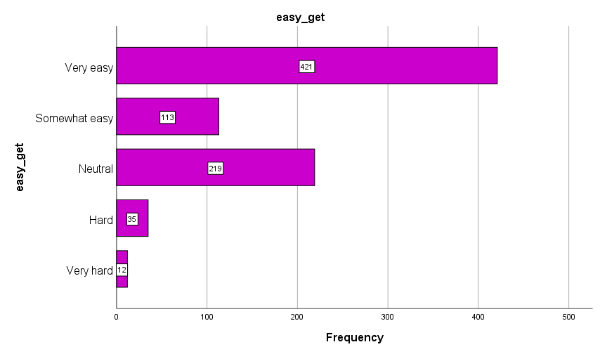

* **FINDINGS**
* The ratings mostly cluster around “3”, implying a **neutral to slightly positive** experience in obtaining an Aadhar card.
* This could indicate a generally smooth but not flawless enrollment process.

Insights from Case Processing Summary:

1 Easy access: 52.6% of respondents find it "Very easy" to get services, and 14.1% find it "Somewhat easy"

2. Challenges: 1.5% find it "Very hard", and 4.4% find it "Hard".

1. **Frequency Table: Comfort in Government Access**

|  |  |  |  |  |  |
| --- | --- | --- | --- | --- | --- |
| **comfort_access** | | | | | |
|  | | Frequency | Percent | Valid Percent | Cumulative Percent |
| Valid | Very comfortable | 689 | 33.8 | 86.1 | 86.1 |
| Somewhat comfortable | 66 | 3.2 | 8.3 | 94.4 |
| Neutral | 21 | 1.0 | 2.6 | 97.0 |
| Somewhat uncomfortable | 14 | .7 | 1.8 | 98.8 |
| Not uncomfortable | 10 | .5 | 1.3 | 100.0 |
| Total | 800 | 39.2 | 100.0 |  |
| Missing | System | 1240 | 60.8 |  |  |
| Total | | 2040 | 100.0 |  |  |

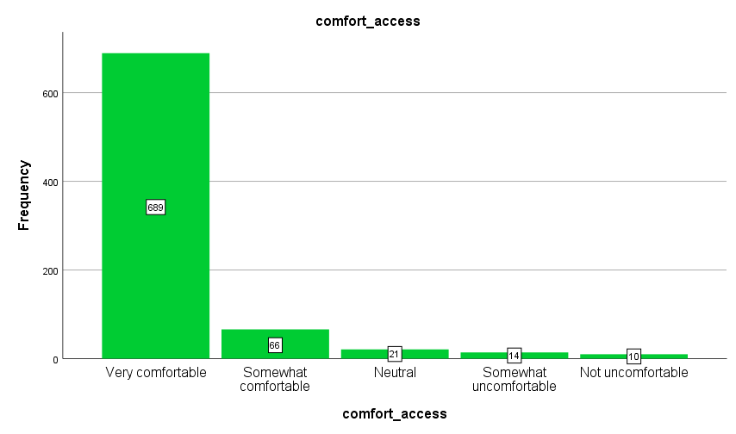

* **FINDINGS**
* A large number of low scores (mostly 1s) highlight a **significant discomfort** with the government having access to personal information.
* This reveals underlying privacy concerns among the population.

**5.Frequency Table: Trust in Government**

|  |  |  |  |  |  |
| --- | --- | --- | --- | --- | --- |
| **trust_govt** | | | | | |
|  | | Frequency | Percent | Valid Percent | Cumulative Percent |
| Valid | Distrust | 10 | .5 | 1.3 | 1.3 |
| Somewhat distrust | 12 | .6 | 1.5 | 2.8 |
| Neutral | 37 | 1.8 | 4.6 | 7.4 |
| Somewhat trustworthy | 277 | 13.6 | 34.6 | 42.0 |
| Very trustworthy | 464 | 22.7 | 58.0 | 100.0 |
| Total | 800 | 39.2 | 100.0 |  |
| Missing | System | 1240 | 60.8 |  |  |
| Total | | 2040 | 100.0 |  |  |

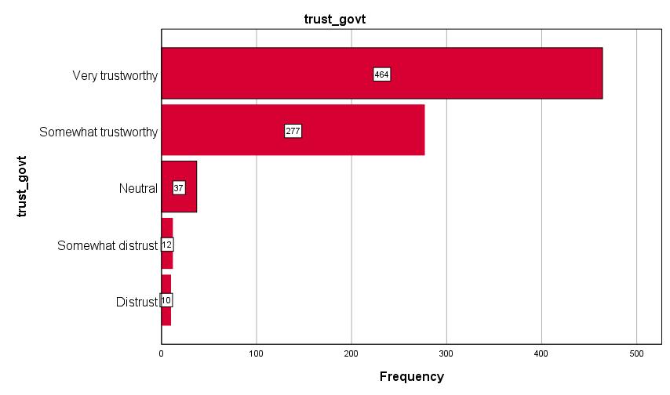

* FINDINGS

Many respondents rated their trust in the government as high (4s and 5s), showing a baseline level of confidence despite privacy concerns.

## **CROSSTABS ANALYSIS**

**Cross-tab and Chi-square (Trust in Govt vs. Gender)**

|  |  |  |  |  |  |  |
| --- | --- | --- | --- | --- | --- | --- |
| **Case Processing Summary** | | | | | | |
|  | Cases | | | | | |
| Valid | | Missing | | Total | |
| N | Percent | N | Percent | N | Percent |
| trust_govt * Gender | 800 | 39.2% | 1240 | 60.8% | 2040 | 100.0% |

|  |  |  |  |  |  |
| --- | --- | --- | --- | --- | --- |
| **trust_govt * Gender Crosstabulation** | | | | | |
|  | | | Gender | | Total |
| Male | Female |
| trust_govt | Distrust | Count | 10 | 0 | 10 |
| % within trust_govt | 100.0% | 0.0% | 100.0% |
| % within Gender | 2.0% | 0.0% | 1.3% |
| Somewhat distrust | Count | 9 | 3 | 12 |
| % within trust_govt | 75.0% | 25.0% | 100.0% |
| % within Gender | 1.8% | 1.0% | 1.5% |
| Neutral | Count | 27 | 10 | 37 |
| % within trust_govt | 73.0% | 27.0% | 100.0% |
| % within Gender | 5.4% | 3.3% | 4.6% |
| Somewhat trustworthy | Count | 188 | 89 | 277 |
| % within trust_govt | 67.9% | 32.1% | 100.0% |
| % within Gender | 37.8% | 29.4% | 34.6% |
| Very trustworthy | Count | 263 | 201 | 464 |
| % within trust_govt | 56.7% | 43.3% | 100.0% |
| % within Gender | 52.9% | 66.3% | 58.0% |
| Total | | Count | 497 | 303 | 800 |
| % within trust_govt | 62.1% | 37.9% | 100.0% |
| % within Gender | 100.0% | 100.0% | 100.0% |

**Interpretation of Crosstab (Trust in Govt × Gender)**

1. **High Trust Dominates**

* 93%+ of both males and females chose *"Somewhat Trustworthy"* or *"Very Trustworthy"*
* Shows widespread confidence in Aadhaar/government services.

1. **Women Express More Trust**
   * 66.3% of women chose *"Very Trustworthy"*, compared to 52.9% of men
   * This skew explains the significant Chi-Square test (p = .001)
2. **Distrust is Minimal and Gendered**
   * All 10 *“Distrust”* responses came from **men only**
   * A very small minority (just 1.3% overall)

|  |  |  |  |
| --- | --- | --- | --- |
| **Chi-Square Tests** | | | |
|  | Value | df | Asymptotic Significance (2-sided) |
| Pearson Chi-Square | 18.522a | 4 | .001 |
| Likelihood Ratio | 22.084 | 4 | .000 |
| Linear-by-Linear Association | 17.450 | 1 | .000 |
| N of Valid Cases | 800 |  |  |
| a. 2 cells (20.0%) have expected count less than 5. The minimum expected count is 3.79. | | | |

**Key Takeaways:**

**1. Significance**

The p-value (.001) is less than 0.05, so the result is statistically significant. Hence, There is a significant association between gender and trust in government.

**2. Strength and Nature of Association**

The Linear-by-Linear Association is also significant (p = .000), suggesting a monotonic trend (e.g., trust level increases or decreases consistently across gender)

**3. Practical Meaning**

* This means male and female respondents differ in how much they trust the government.
* Males may show higher trust in Aadhaar/government than females Or females may be more neutral (cross-tabulation counts and percentages to describe which gender trusts more and at what level)

**4. Warning – Small Expected Counts**

* SPSS notes that 20% of cells have expected counts < 5, which can affect the reliability of the test.
* If this issue is severe, categories should be merged. (e.g., combine “Strongly Agree” and “Agree”) Or use Fisher's Exact Test

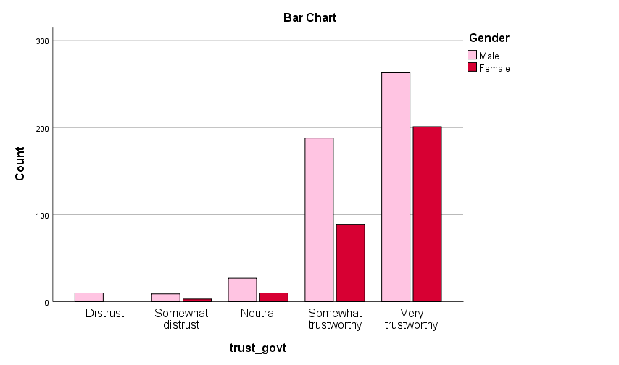

## **Comparing Means (Trust by Age)**

|  |  |  |  |  |  |  |
| --- | --- | --- | --- | --- | --- | --- |
| **Case Processing Summary** | | | | | | |
|  | Cases | | | | | |
| Included | | Excluded | | Total | |
| N | Percent | N | Percent | N | Percent |
| trust_govt * Age | 800 | 39.2% | 1240 | 60.8% | 2040 | 100.0% |

|  |  |  |  |
| --- | --- | --- | --- |
| **Report** | | | |
| trust_govt | | | |
| Age | Mean | N | Std. Deviation |
| 0 | 4.78 | 18 | .428 |
| 18-28 | 4.50 | 250 | .701 |
| 29-39 | 4.40 | 251 | .816 |
| 40-50 | 4.43 | 212 | .832 |
| 51-61 | 4.66 | 56 | .549 |
| 62 & above | 4.46 | 13 | .660 |
| Total | 4.47 | 800 | .763 |

**Conclusions**

* Overall trust levels are high, with all groups above 4.4 on average.
* A U-shaped pattern is observed: younger and older age groups report higher trust, while middle-aged respondents (29–50) are slightly more skeptical.
* Standard deviations are lowest in the youngest (0) and older (51–61) groups, indicating more agreement within these groups.

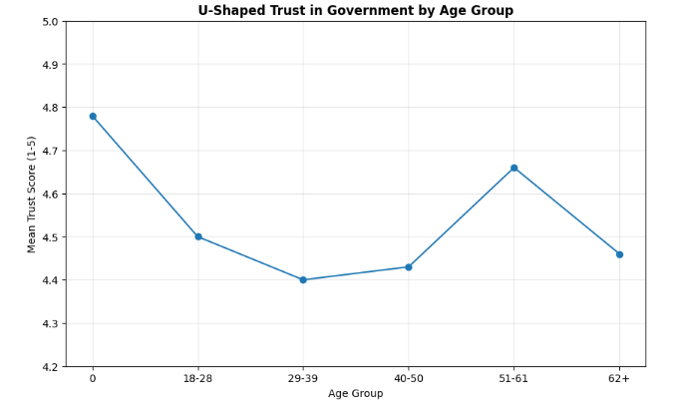

**Open-ended Comments (PART C)**

**Aadhar Benefits**

| **Code** | **Theme** | **Frequency** | **% of Respondents** | **Interpretation** |
| --- | --- | --- | --- | --- |
| B4 | Easier Banking | 186 | 23.2% | Most commonly cited benefit — Aadhar has significantly streamlined bank account opening. |
| B2 | Used as ID Proof | 94 | 11.8% | Widely recognized as a valid and useful identity document. |
| B3 | Access to Welfare Schemes | 81 | 10.1% | Aadhar facilitates access to government benefits. |
| B5 | Corruption Reduction | 83 | 10.4% | Perception that Aadhar promotes transparency. |
| B1 | Simplified Government Processes | 53 | 6.62% | Users feel government tasks have become easier. |
| B6 | LPG Subsidy | 15 | 1.88% | Limited specific mentions, but still important for targeted beneficiaries. |
| B7 | Easier Admissions/Education Use | 32 | 4.0% | Aadhar helps streamline educational formalities. |
| **Other** | Miscellaneous or vague responses | 256 | 32% | High proportion of uncategorized responses — likely due to broad or unclear statements. |

Entries are encoded as follows using R Programming :-

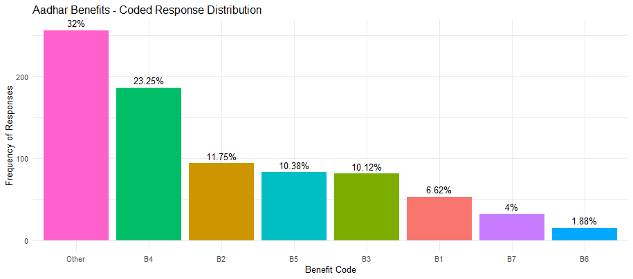

**Conclusion:** Aadhar’s most tangible impact is in banking access (23.2%), followed by its role as an ID and welfare enabler (~11% each). A substantial 32% of responses were too varied to classify under fixed codes — suggesting diverse perceptions.

Frequently mentioned advantages include:

* + Easier access to government subsidies and benefits
  + Help in opening bank accounts
  + Support in crime prevention and fraud reduction (e.g., SIM card misuse)
  + Streamlined KYC processes

These responses reflect a **positive perception of Aadhar as a unifying ID** that eases bureaucratic processes.

**Aadhar Limitations**

| Code | Theme | Frequency | % of Respondents | Interpretation |
| --- | --- | --- | --- | --- |
| C7 | No Challenges Reported | 681 | 85.1% | Majority experienced a smooth Aadhar experience. |
| C5 | Excess Formalities | 20 | 2.5% | Bureaucracy still an issue for some. |
| C1 | Repeated Visits/Delay | 17 | 2.12% | Indicates operational inefficiencies in issuance or updates. |
| C3 | Technical Errors (printing etc.) | 12 | 1.5% | Minor but present technical issues. |
| C6 | Data/Privacy Concerns | 3 | 0.38% | Similar to limitation themes — still low frequency. |
| C4 | Middlemen/Broker Exploitation | 2 | 0.25% | A few mentioned being charged or misled. |
| Other | Miscellaneous | 65 | 8.12% | Broader range of isolated or unclear concerns. |

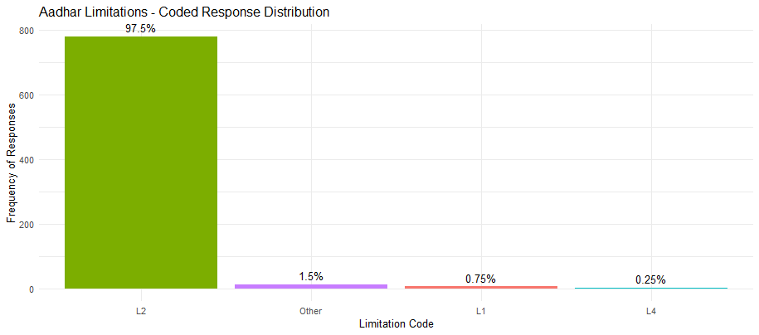

**Conclusion:** The program is perceived to run smoothly for most users (85%), though challenges with access or technical issues persist for a small group

* Many responses simply stated “NONE”, indicating that a large segment of participants does not perceive significant drawbacks.
* Some of the issues reported are:
  + Data breaches
  + Identity theft concerns
  + Technical failures at authentication points

This suggests that while trust is generally high, **tech literacy and awareness about digital risks** remain areas for improvement.

**Aadhar Challenges**

| **Code** | **Theme** | **Frequency** | **% of Respondents** | **Interpretation** |
| --- | --- | --- | --- | --- |
| **C7** | No Challenges Reported | **681** | **85.1%** | Vast majority reported no issues — indicates smooth enrollment/use. |
| **C5** | Excess Formalities (Paperwork, Docs) | 20 | 2.5% | Some find the process bureaucratic or complex. |
| **C1** | Repeated Visits, Delays | 17 | 2.12% | Occasional inefficiencies in Aadhar centers; delays in issuing/updating cards. |
| **C3** | Technical/Printing Issues | 12 | 1.5% | Includes print errors, data mismatch, etc. |
| **C6** | Privacy/Data Sharing Concern | 3 | 0.38% | Small group concerned about data safety or leaks. |
| **C4** | Middlemen/Brokers Exploiting Process | 2 | 0.25% | Very limited mention of unofficial agents charging money. |
| **Other** | Miscellaneous issues | 65 | 8.12% | Mixed responses — includes vague, unrelated, or less common challenges. |

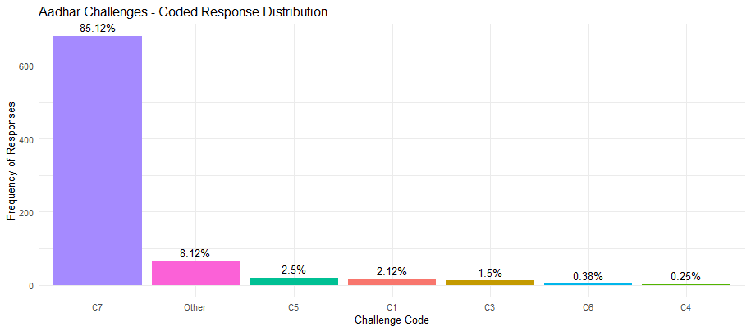

**Interpretation & Insight:**

* **Strong positive experience overall**: With 85.1% not reporting any challenges, the Aadhar system appears to be largely user-friendly and functional.
* However, administrative and technical inefficiencies persist:
  + Red tape (C5) and delays (C1) indicate areas for process improvement.
  + Technical errors (C3) and even minor privacy concerns (C6) show that trust can be further strengthened with transparency and better service delivery.
* **8% “Other” responses** suggest there's still some diversity of issues that aren’t captured by the fixed categories — future surveys could probe these in more depth.
* Common themes (where mentioned) include:
  + Connectivity issues in rural areas
  + Difficulty in updating Aadhar details
  + Lack of awareness among illiterate or elderly citizens
* Many again reported “NONE”, reinforcing that challenges are **either minimal or under-recognized**.

**Summary Interpretation for open ended Comments**

* Aadhar is largely seen as a positive force—especially in terms of accessibility to services and government benefits. Widespread satisfaction with Aadhar’s role, especially in banking, identity verification, and government services.
* Concerns remain around data privacy and government surveillance, especially among digitally aware users. Very few respondents express concerns about privacy or misuse, possibly indicating low awareness or trust in government safeguards.
* Trust in the government is relatively strong, even though comfort with sharing personal data is low.
* A notable portion of users reports no significant issues, suggesting wide acceptance, but possibly also a lack of awareness of potential limitations.
* Improvements in system transparency, grievance redressal, and privacy policies could boost public confidence further.